Materials and Copyrights

There are common recommendations how to develop test scenarios of architecture mechanisms illustrated as test scenarios of RDBM and Communication architecture mechanisms creation in this document.

All the examples do not contain any commercial or technological information and are used only as illustrations to main ideas.

Common recommendations to develop test scenarios of architecture mechanisms

Before you start reading this material we recommend you to read SADD-MTHD-03-Architectural Mechanism.doc

Target group of the document:
Architects, System analysts, Project Managers, Project Sponsor, test Manager and other project stakeholders .

The Goal of test scenarios development
to test working and quality if architecture mechanism implementation in according to functional, non functional and quality attributes.

Below you will find out the main recommended test scenarios kinds which might be used to test the architecture mechanism.

While you are creating test scenarios list it is recommended to group all the test scenarios by test scenarios types::
- Main operations,
- Multi-user mode and conflicts resolution
- Reliability and fault tolerance,
- Productivity and scalability,
- Monitoring.

Main operations
Test cases of this types are to test functional abilities of architectural mechanism and are mandatory.

CRUD operations for main object types

CRUD means the main operations under data that stored somewhere in a data storage:
Create,
Read (Retrieve),
Update,
Delete (Destroy)

First of all you must elicit all the main object types which this mechanism works with. For every such type you have to test CRUD operations.

Read (Retrieve) operation assumes as getting object by its identifier (by uncial key), and objects searching by any allowed searching criteria.

If there searching methods with the fixed searching parameters, we recommend to include them to separate test cases.

The Read (Retrieve) operation also includes case to get all the objects without any filtering but with object list formed by pages.

CRUD operations for objects relations
While analyzing objects on CRUD the objects relations are elicited. If it is necessary (from the logic of the system perspective) to consider relations while CRUD, you have to create separate test cases for this.

For example, when system CRUDs the parent / child objects.

The Update operation assumes any possible change of object state, attributes, related objects and relations to objects.

Optional Business Cases
If architectural mechanism realizes specific operations with the objects or / and is traced from the architectural significant requests, than for every such operation there must be test case.

Also if there are business rules or data verification constraints in the architecture mechanism function, you have to check it by test cases.

Multi-user mode and conflicts resolution
Test cases of this type are to test functionality of architecture mechanism and are mandatory, it multi user mode is required for the system.

Client sessions principles
It is necessary to realize emulation processes to emulate system work in multi user mode.
Create emulation or use already realized architecture mechanisms such as client session management, authentication, authorization, access by roles.
It is preferable to use automated tools to imitate work in the multi user mode.

Main operations for number of sessions and conflict resolution
Create test cases to check parallel operations which were initiated by different clients sessions. Check the conflict resolution during concurrency access to the shared resources.
If there is Conflict resolution mechanism in the architecture conception, you will need to develop integrated test scenarios to check chain from the initiator up to shared resources and to the Conflict resolution mechanism and back to the initiators of concurrent data access.

Reliability and fault tolerance
Test cases of this type are both to test functionality of architecture mechanism and to test work quality criteria in the critical situations and are desirable.

Exception processing
In according to the formed before exception list, the procedure of exception processing is created. For every exception type there is separate test scenario.
If there is exception generation in the system, you have to check them by test cases too.
The Best Practice to realize exception management with the help of the Exception Management architectural mechanism.

Transactions
If architectural mechanism is suitable to work in a transaction mode you have to check out it. It means to create such test scenarios where the whole transaction both ends successful and non successful.

Stress testing
It is necessary to develop test cases for stress testing. It is recommended to use automated tools for this purpose.

Productivity and scalability
Test scenarios of this type usually to test architecture mechanism quality criteria in the critical situations and are desirable.
To measure productivity the productivity counters might be used.

Asynchronous operations
If there are asynchronous operations in the architecture mechanism functionality, these operations must be tested.

Multi threads
To increase productivity the multi threads might be used. If there are multithreads in the architecture mechanism functionality, then you must develop test cases to test the mechanism working with different number of threads and to test threads management and control (if applicable to the mechanism functions).
If there is Multi-threads management mechanism in the architecture conception, you will need to develop integrated test scenarios to check chain from the initiator up to this mechanism and back to the initiator.

Profiling anв realization optimization
It productivity attributes are not suitable you may try to use applications profiling tools to find out a bottlenecks in the architectural mechanism realization.

Scalability
To test scalability it is necessary to test productivity of the application in different working environments.

Monitoring

Logging
If there is a logging functionality in the system it is recommended to realize it as separate architectural mechanism Logging. It must be tested by special developed test cases.

Change history
If there is change history functionality in the system it is recommended to test it by special developed test cases.

Notifications
If there is notification functionality in the system it is recommended to test every notification type for every subsystem, outer systems and other architectural mechanisms by special developed test cases.

“ZZZ” project. Test Scenario example for Communication Architectural Mechanism.

The purpose of architecture mechanism creation
It is necessary to design vertical prototype to research and test remote interaction with the help of WCF (Windows Communication Foundation).

The architecture mechanism prototype must include the whole chain of interaction from user interface to architecture mechanism and to the data storage through DAL and back to the user interface. The special attention must be given to server and client of mechanism all the rest may be realized minimally.

Test scenarios survey
Every test scenarios use the same data type “Document” to work with. “Document” has the following structure::
ID
Name
Creation Date
Update Date
Content

All the test scenarios are divided into 3 groups:
Main operations testing
Add object
Change object
Delete object
Get list of all objects
Get object by ID
Multi-user access
Main operations with object from different users (without conflict resolution testing)

Productivity for different bindings
As content of “Document” object the binary data are used
Test binary data sending for different types of bindings
Compare productivity of different bindings
Measure data client-server transfer parameters
Test fault tolerance of prototype
Test prototype when connection is lost (server is abnormally terminated)
Test client abnormal termination while server is being processed its request

Additional tests:
Test automated notification about large amount of data transfer
Test server notifications on the client side
While testing productivity the productivity counters must be used

Test Scenarios

Use Case diagram
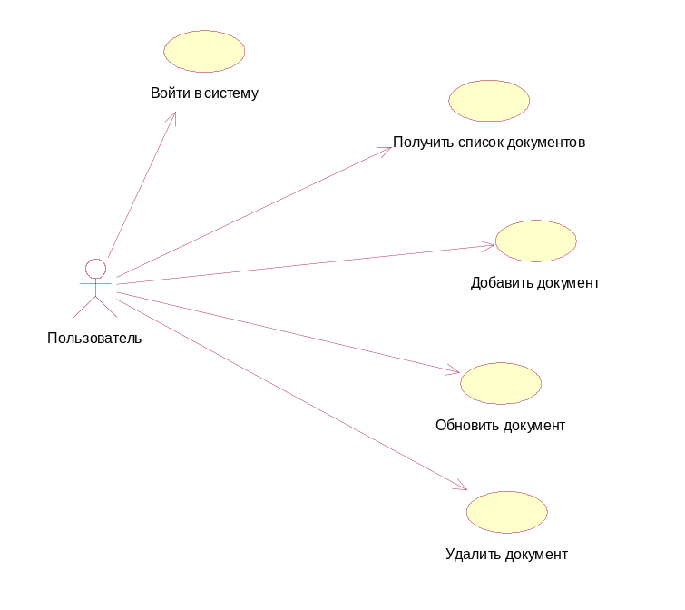

Add Document
The robustness diagram for “Add Document” use case is shown below
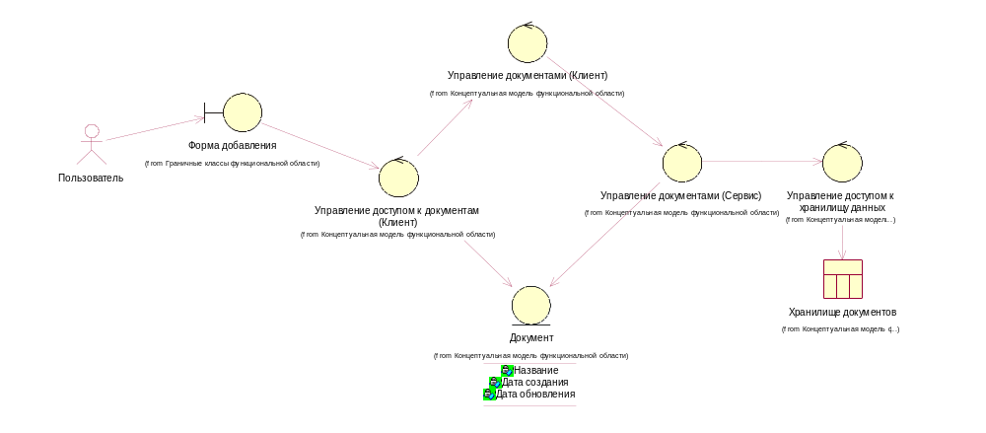
The sequence diagram for “Add document” is shown below:
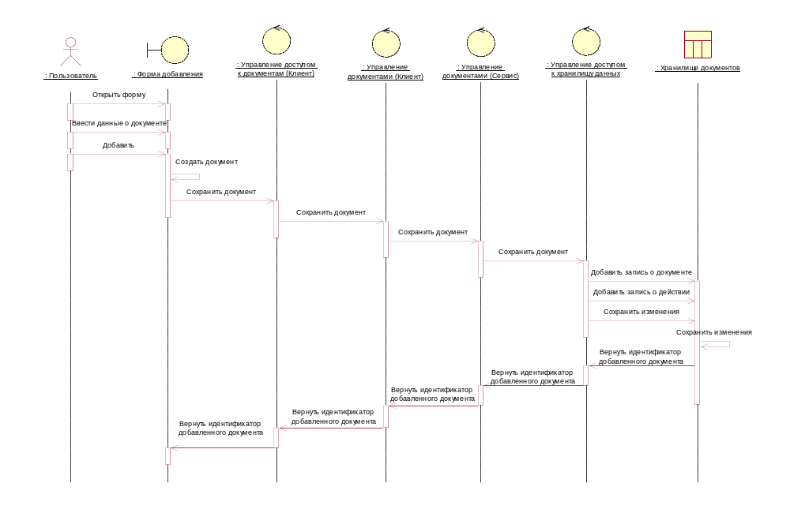

Update Document
The robustness and sequence diagram for this use case looks like the ones for the “Add Document” use case.

Delete Document
The robustness and sequence diagram for this use case looks like the ones for the “Add Document” use case.

Get Document List
The robustness and sequence diagram for this use case looks like the ones for the “Add Document” use case.

Domain Obect Model. Main entities.
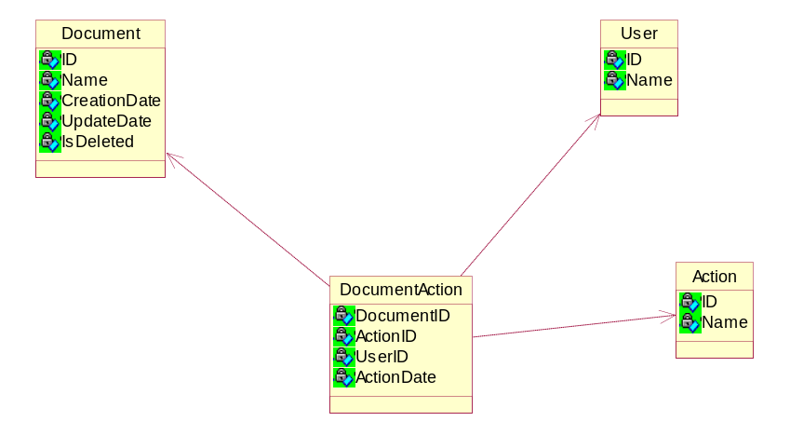

Class diagram

Contract
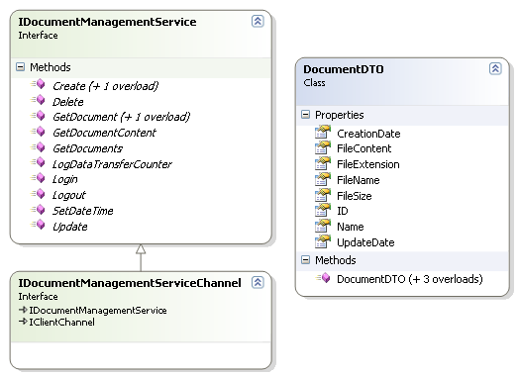

Database
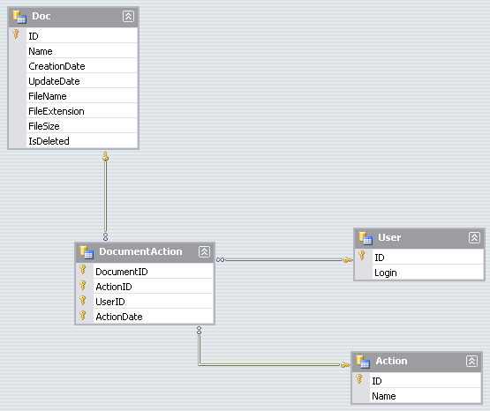
Схема данных
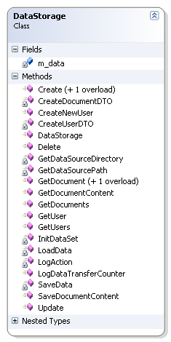
Data Access Object

Service (Application Server)
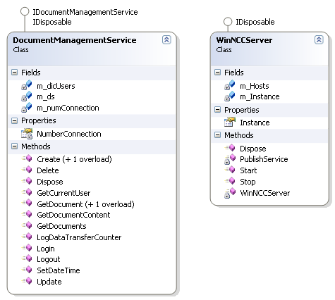

Service (Client)
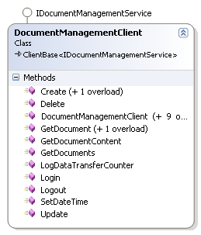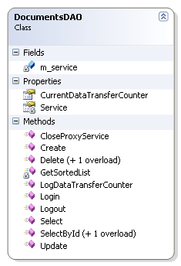

Component Model
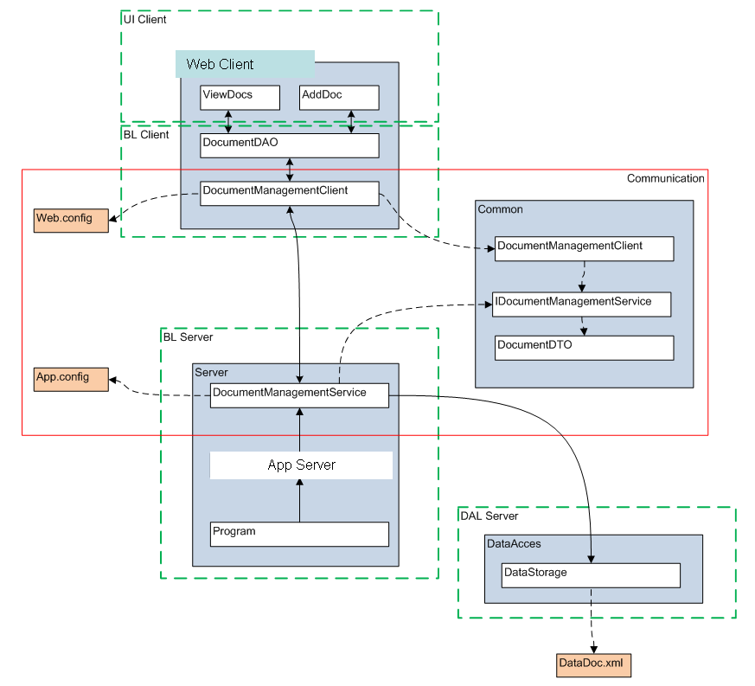

Test results

Main operation tests
The main operations with the business objects testing and the multi user testing were done successfully.

Productivity tests
The test results can not be used as absolute values and should be considered as the basis for evaluation so as these test results are depends on the working environment and on the current system state.

Single PC Test (test was performed in Debug mode)
Test environment:
CPU: X
RAM: Y Gb
OS: Windows XP SP 3
.NET: 3.5 SP 1
Binding Configuration (NetTcpBinding):
<netTcpBinding>
<binding name="NetTcpBinding_IDocumentManagementService" … … >
…
</binding>
</netTcpBinding>

File Size, bytes | Data transfer direction | Transfer duration, sec
File Size, bytes | Data transfer direction | Client BL | Client Server Communication | Server BL | Server DataSource Exchange
2 483 | ClientToServer | 0,078 | 0,250 | 0,031 | 0,016
2 483 | ClientToServer | 0,000 | 0,000 | 0,000 | 0,016
2 483 | ClientToServer | 0,047 | 0,016 | 0,000 | 0,063
48 987 982 | ClientToServer | 0,126 | 0,894 | 0,000 | 0,753
2 483 | ServerToClient | 0,031 | 0,062 | 0,000 | 0,000
2 483 | ServerToClient | 0,000 | 0,031 | 0,000 | 0,000
2 483 | ServerToClient | 0,000 | 0,047 | 0,000 | 0,016
48 987 982 | ServerToClient | 5,461 | 1,033 | 0,000 | 0,141
48 987 982 | ServerToClient | 0,000 | 1,111 | 0,000 | 0,125
48 987 982 | ServerToClient | 5,618 | 0,986 | 0,000 | 0,125

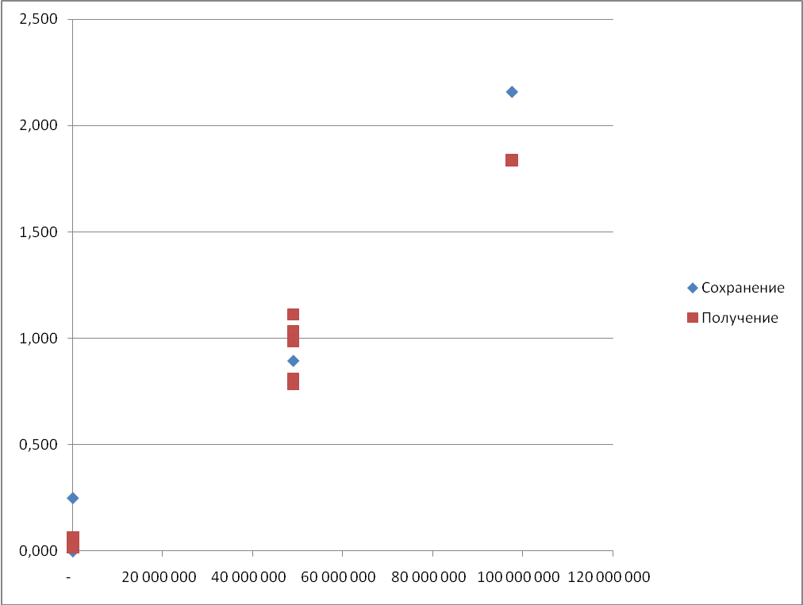

Two PCs Tests
Client Application test environment:
CPU: X
RAM: Y Gb
OS: Windows XP SP 3
.NET: 3.5 SP 1

Application Server test environment:
CPU: XX
RAM: YY Gb
OS: Windows XP SP 3
.NET: 3.5 SP 1

Binding Configuration (NetTcpBinding):
<netTcpBinding>
<binding name="NetTcpBinding_IDocumentManagementService" … …>
… …
</binding>
</netTcpBinding>
File Size, bytes | Data transfer direction | Transfer duration, sec
File Size, bytes | Data transfer direction | Client BL | Client Server Communication | Server BL | Client BL
2 483 | ClientToServer | 0,000 | 0,000 | 0,000 | 0,016
97 573 316 | ClientToServer | 0,797 | 15,725 | 0,000 | 1,672
2 483 | ServerToClient | 0,062 | 0,016 | 0,000 | 0,000
2 483 | ServerToClient | 0,016 | 0,047 | 0,000 | 0,000
48 987 982 | ServerToClient | 13,703 | 6,517 | 0,000 | 0,078
97 573 316 | ServerToClient | 15,125 | 11,786 | 0,000 | 0,219

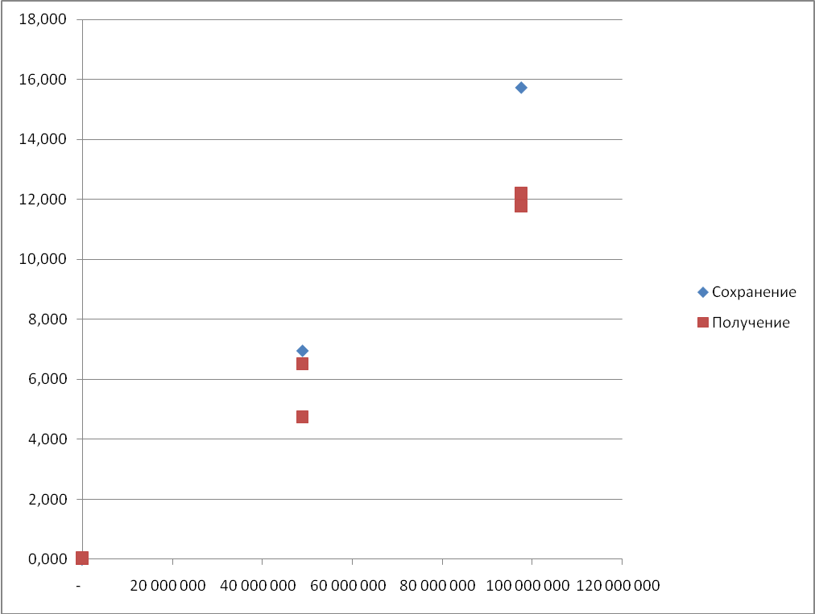

Three PCs Tests
Web-access to client application PC characteristics:
CPU: X
RAM: Y
OS: Windows 2003 Server R2 SP2
.NET: 3.5 SP 1

Client Application test environment:
CPU: XX
RAM: YY
OS: Windows 2003 Server R2 SP2
.NET: 3.5 SP 1

Application Server test environment:
CPU: XXX
RAM: YYY
OS: Windows 2008 Server
.NET: 3.5 SP 1

Data volume, Kb | Number of users | Average data transfer duration, sec
10240 | 5 | 0,17
10240 | 10 | 0,04
10240 | 100 | 0,05
102400 | 5 | 0,25
102400 | 10 | 0,32
102400 | 25 | 0,28
1024000 | 10 | 0,41
1024000 | 25 | 0,41
1024000 | 50 | 0,25

